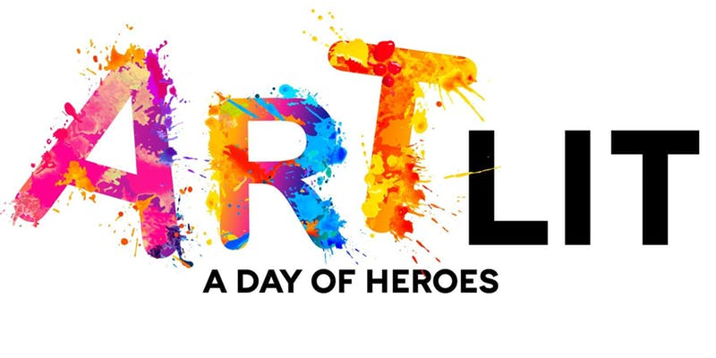

ArtLit is a community celebration of art and literature. This year’s theme, “A Day of Heroes”—will take over the areas surrounding the Pompano Beach Library & Cultural Center with a playful explosion of live chalk art, canvas art, music, virtual reality demonstrations, interactive experiences and fun for all ages. Everyone is invited to join in a day of artful literary entertainment--a perfect way to celebrate Pompano Beach Library & Cultural Center’s one-year birthday.
Chalk artists of all ages are invited to participate in Art Lit 2019. To apply as a featured chalk artist or school group, please complete the application below and email to carriebennettart@gmail.com
The chalk portion of the event will be Saturday, January 19th from 10-5pm, with live painting taking place 6-10pm. Refreshments will be provided for artists.
50 W. Atlantc Blvd, Pompano Beach FL 33060
Art Lit Eventbrite Link
Art Lit Chalk Artist Application

Name: _________________________
Phone: ______________________
Address: __________________________________
Email: _________________________
Street Art Experience: _______________
Facebook: ____________________________________
Twitter: ______________________________________
Website: _____________________________
Professional Chalk Artist: ______
Intermediate Chalk Artist: ______
Student Artist (indicate school): _____

Artist will be assigned a 4 x 6’ vertical space. If you desire a different size or orientation, please indicate here: ___________________________________________________________
Will anyone else be chalking with you? __________________________

*Application Deadline: December 16th, 2018

Chalk Art Guidelines:
- Artwork must be family friendly & appropriate for all viewers
- No nudity or political statements will be accepted
- Artwork will contain no advertising symbols
- Artwork may not violate any copyright laws
- Your space should be filled and contained to assigned parameters
- Artist must complete their assigned square by the end of the day
- Only non-toxic soft pastels may be used. Use of any other material is forbidden (i.e. oil pastels, acrylic, gouache, markers, etc.)
- Artist's will need to submit a sketch of what you would like to create for Art Lit upon being selected for the event
- Theme is “A Day of Heroes”, interpretation is open following the guidelines listed above

I agree that The Pompano Beach Library and Cultural Center reserves the right to photograph any artwork created during the event.

Signature: _______________________ Date: _______________

