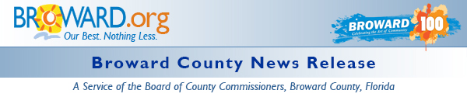

Third Annual Go SOLAR Fest Set for October
DATE: September 3, 2015
MEDIA CONTACT: Kay Sommers
Environmental Protection and Growth Management
PHONE: 954-519-1257
EMAIL: ksommers@broward.org
BROWARD COUNTY, FL - Get 4 FREE Florida Building Commission Advanced Code CEUs. The course, “Advanced Residential Energy Code Compliance: Methods, Tools and Verification” is sponsored by the Go Solar Florida Team, the Department of Business and Professional Regulation and the Florida Building Commission.
Who: Professionals who are licensed by the following Boards:
- Construction Industry Licensing Board (CILB)
- Building Code Administrators and Inspectors (BCAI)
- Board of Landscape Architects (BOLA)
- Electrical Contractors Licensing Board (ELCB)
- Florida Board of Professional Engineers (FBPE)
When: October 9, 2015 – 9 A.M. to 1 P.M.
Where: 3rd Annual Go SOLAR & Renewable Energy Fest
Greater Fort Lauderdale/Broward County Convention Center - Hall B, Room 113 1950
Eisenhower Blvd Ft Lauderdale, FL 33316 (Free Admission and Parking)
This FREE course will provide students with an overview of the science of energy use contributors in buildings, energy code compliance methods, tools and field verification issues, and prepare them to address common questions. The course is comprised of three main sections-- Building Science, The Residential Florida Energy Code (including a discussion of compliance and energy saving improvement options), and Residential Energy Code Forms. The primary objective is for students to obtain a working knowledge of the Florida residential energy code compliance methods, the tools that are used for determining compliance, and how to verify compliance at permitting and in the field.
To earn 4 free advanced code continuing education hours sponsored by Go SOLAR Florida, Department of Business and Professional Regulation, Florida Building Commission and BASF, please complete the registration information located on the Go Solar Fest web site gosolarflorida.org and fax to 352-392-9033.
The U.S. Department of Energy (DOE) has awarded the Go SOLAR - Florida team a $1.6 million SunShot Initiative Rooftop Solar Challenge II competitive award to make it easier for Floridians to obtain grid-tied solar installations. Go SOLAR Florida is one of eight recipients of the award nationwide. Its purpose is to increase the use of and access to solar energy among the state's residents and businesses over the next two and a half years.
The Go SOLAR Florida team is a partnership of Florida counties, cities, the Florida Solar Energy Center and Florida Atlantic University representing approximately 4 million Floridians. For more information on the partnership, visit the Go SOLAR website.

Release Properties

 | Date: | 9/3/2015 9:14 AM
 | Keywords: | Community, Energy, Environment, Events, Exhibits, Small Business, District 1, District 2, District 3, District 4, District 5, District 6, District 7, District 8, District 9
 | News Type: | News Release

