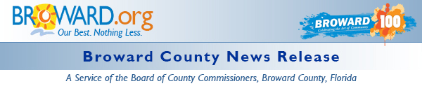

Renew a Life - Adopt a Pet at the Third Annual Go Solar Fest
DATE: September 23, 2015
MEDIA CONTACT: Lisa Mendheim, Animal Care and Adoption Division
PHONE: 954-359-1010
EMAIL: lmendheim@broward.org
BROWARD COUNTY, FL - Visitors to the Third Annual Go Solar Renewable Energy Fest will not only be able to learn about renewable energy, but will also be able to renew the life of a pet in need by adopting a dog or cat at the event.
Broward County Animal Care will be offering lovable dogs and cuddly cats for adoption at the Go Solar Fest on Saturday October 10th, from 10AM to 4PM. This free event is being held at the Greater Fort Lauderdale - Broward County Convention Center, 1950 Eisenhower Boulevard, Fort Lauderdale.
All adoptions will include spaying/neutering, all necessary vaccinations, Broward County Pet Registration tag, a microchip and, for the first fifteen adoptions, a free LED-Lighted USB/Solar Rechargeable Dog Collar.
Go SOLAR Florida is sponsoring the Third Annual Go SOLAR & Renewable Energy Fest on Friday, October 9th from 10AM to 5PM and on Saturday, October 10th from 10AM to 4PM. The event is to educate businesses and residents on solar and renewable energy. Pre-registration is required. This year, the exhibit hall will be on the ground floor of the convention center. This will enable alternative fueled vehicles, vans, and trailers to be inside with the other exhibitors.
The U.S. Department of Energy (DOE) has awarded the Go SOLAR - Florida team a $1.6 million SunShot Initiative Rooftop Solar Challenge II competitive award to make it easier for Floridians to obtain grid-tied solar installations. Go SOLAR Florida is one of eight recipients of the award nationwide. Its purpose is to increase the use of and access to solar energy among the state's residents and businesses over the next two and a half years.
The Go SOLAR Florida team is a partnership of Florida counties, cities, the Florida Solar Energy Center and Florida Atlantic University representing approximately 4 million Floridians. For more information on the partnership, visit the Go SOLAR website. For additional information about Third Annual Go SOLAR & Renewable Energy Fest, contact Kay Sommers at 954-519-1257 or ksommers@broward.org.
About Animal Care
Broward County Animal Care and Adoption is dedicated to providing shelter for lost and homeless animals. The agency provides access to hundreds of shelter pets hoping for a new home. Please prevent unwanted animals and have your pet spayed or neutered. For more information about the agency, visit our website, or "like us" on Facebook.com/BrowardPets.

Release Properties

 | Date: | 9/22/2015 10:13 AM
 | Keywords: | Animal, Energy, Exhibits, District 1, District 2, District 3, District 4, District 5, District 6, District 7, District 8, District 9
 | News Type: | News Release

