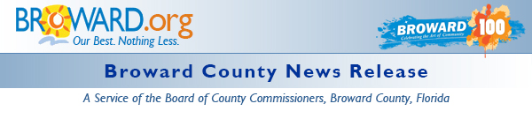

Third Annual Go SOLAR Fest Set for October
DATE: August 10, 2015
MEDIA CONTACT: Kay Sommers
Environmental Protection and Growth Management
PHONE: 954-519-1257
EMAIL: ksommers@broward.org
BROWARD COUNTY, FL - The Third Annual Go SOLAR & Renewable Energy Fest will be held in October at the Broward County Convention Center. Go SOLAR Florida will sponsor this FREE event, which includes free parking, to educate businesses and residents on solar and renewable energy. The Fest will run from 10AM-6PM Friday, October 9th, and from 10AM-4PM Saturday, October 10th. Pre-registration is required to attend, exhibit or be a sponsor. This year, the exhibit hall will be on the ground floor of the convention center, which will enable alternative fueled vehicles, vans, and trailers to be inside with other exhibitors.
Small exhibitor space, 100 square feet, will only cost $100. Small businesses are encouraged to participate. As a result of surveying past Fest participants, there will be less emphasis on training and greater emphasis on exhibitors. Meeting space will be available for exhibitors to give detailed presentations on their products and services to participants.
Sponsors are being sought to help defray the expenses of this event which enables the Fest to keep exhibitor prices low. An array of options and price ranges are available for cash sponsors and in-kind sponsors are welcome too. Available sponsorships can be found here.
Payment by exhibitors and sponsors can be made by credit card (no service fee) or by check. Attendees, exhibitors and sponsors can use another option to register online at Eventbrite. While convenient, there is a service charge for exhibitors and sponsors on the Eventbrite site.
Fest organizers are seeking training partners who will offer Continuing Education Units (CEUs) as a way to attract more attendees. Some options would include CEUs for Planners, LEED Certification, Building Officials, etc. If you know of a training partner or have specific training and you would like to attend, please email Kay Sommers.
The U.S. Department of Energy (DOE) has awarded the Go SOLAR - Florida team a $1.6 million SunShot Initiative Rooftop Solar Challenge II competitive award to make it easier for Floridians to obtain grid-tied solar installations. Go SOLAR Florida is one of eight recipients of the award nationwide. Its purpose is to increase the use of and access to solar energy among the state's residents and businesses over the next two and a half years.
The Go SOLAR Florida team is a partnership of Florida counties, cities, the Florida Solar Energy Center and Florida Atlantic University representing approximately 4 million Floridians. For more information on the partnership, visit the Go SOLAR website.

Release Properties

 | Date: | 8/10/2015 9:14 AM
 | Keywords: | Community, Energy, Environment, Events, Exhibits, Small Business, District 1, District 2, District 3, District 4, District 5, District 6, District 7, District 8, District 9
 | News Type: | News Release

