Go Solar Florida Partners’ Meeting
July 25, 2014
Broward County Government Center West
8:30 a.m.

Roll Call
- Alachua - Jeff Hays
- Broward County - Kay Sommers, Ken Dobies, Matt Anderson, Sean Sammon, Andrea Bousquet, Jason Liechty, Cathy Randazzo, Michael Huneke, Icilda Humes, Scott Strauss
- Miami Dade - Boris Sursky, Mike Goolsby, Patricia Gomez
- Orange County - Renee Parker, Aneta Duhig
- FSEC - Steve Barkaszi, Colleen Kettles
- City of Venice- Vince LaPorta, Karen Butterworth
- FAU - Dianna Mitsova
- Monroe County – no representative
Updates
Website
- Go Solar Florida website (www.gosolarflorida.org) is updated regularly. Partners were encouraged to access meeting information, resource documents, etc. from the website. See pages five-seven for details.
- Partners were asked to utilize the Go Solar Florida logo and letterhead and to share meeting agendas, minutes, and sign-in sheets for posting to the webpage.
- Partners were referred to the existing marketing plan available on the Marketing committees page.

Contracts

- The FSEC contract has been returned and is awaiting countersigning.
- The Orange County contract is being presented to its Board for consideration and approval at its meeting next week.
- Monroe and Miami-Dade Counties are reviewing their contracts.
- City of Venice indicated that they would prefer to have the new zoning ordinance changes in place before they sign their contract. It was suggested that the Broward County attorney’s office reach out to City of Venice’s attorney to discuss the way forward.

Plans/Plans Approval Team
- FSEC’s plans system is presently being worked on. A rudimentary demonstration of the electric drawings will be available soon.
- The team is also working on the certification process.
- A master design manual file system certified by engineers with third party reviews will be used.

Business Requirements/Plan
- An initial outline of the objectives has been drafted.
- The requirements are being updated continuously to reflect progress.
- This business requirements/plan will detail what system design tools are needed and how it will generate designs from user input.
- Plans (electrical and structural) will be code compliant and will not be static but rather will be created as needed in order to ensure future compatibility.
- The development version is the 2011 NEC.
- A detailed version of the plan will be forwarded to the plans approval team while a summary will go to all partners. Bi-monthly updates on the plan will be circulated.
- The first version of the plan is being fine-tuned and will be forwarded to the team for review within the next few weeks.

Permitting/Application Team
- The team is working on the basic concept for the permitting application.
- The team is revising the draft business document; thereafter it will be forwarded to the partners for consideration.

Planning and Zoning Team
- Alachua County will adopt the planning and zoning ordinance in August.
- The best practices document is being drafted and will be forwarded for review next week.
- Cathy Randazzo met with Dr. Mitsova who provided her with research findings that will be useful for inclusion in the best practices document.

Financial Team
- The Financial Action Plan team has been activated.
- An outline of the action plan as well as resource documents such as solar incentives in the state, have been shared with the team. The draft of the plan will be developed over the next week and shared with partners for feedback.
- A meeting was convened by Broward County to discuss solar leasing and the Tangible Personal Property (TPP) Tax on leased property. Efforts are underway to explore strategies to approach the legislature about redefining pollution prevention equipment for tax break purposes.
- City of Venice committed to identifying someone from its jurisdiction to serve on this team.

Marketing
- The Go Solar Fest report, inclusive of best practices, lessons learned, and marketing tools, etc. is being finalized.
- The presentation videos from the fest are being edited and will be posted online shortly.
- Go Solar templates, for use on letterheads, meeting minutes/agenda etc., will be forwarded to partners.
- Go Solar marketing materials including promotional items are available to partners.

Florida Solar Users Network (S.U.N.)
- A solar industry advisory council (Florida Solar Users Network) is being convened by FSEC as a part of the project. The purpose of the group is to get industry buy-in for Go Solar, to get an understanding of any issues that stakeholders may have with respect to the project, and to keep stakeholders engaged.
- Thus far, there are about 10 solar contractors identified for membership to the group. A conference call with these individuals will be scheduled for next week.
- Partners were encouraged to suggest individuals for nomination to the group, but were cautioned that the group is only looking for members who will offer constructive criticism.
New Issues
Solar Ready Florida
- This group is a recipient of a DOE grant and its effort are led by the National Association of Regional Council of State Governments. There are overlapping objectives of Go Solar Florida and Solar Ready Florida.
- It was suggested that this group could serve as a resource for the proclamation endorsement component of the grant.

Prepare now for 2015 Legislative Session
- Broward County has an in-house lobbyist. The matter of responding to repeat efforts to reduce FSEC’s authority will be discussed internally and language will be drafted with respect to giving authority to FSEC.
- There has been recent opposition in the media to the issue of net metering. Jason Liechty (Broward County) volunteered to draft a policy statement on net metering and other issues that could be adopted by resolution.

Reactivation of PR/Marketing Team
- There are 3 main audiences for marketing efforts namely: legislature, contracting industry, and rack manufacturers.
- It was suggested that a survey be used as a baseline for what these audiences want from the project.
- It was suggested that workshops, seminars, webinars, and public outreach via utility companies’ mail-outs also be included as a part of the marketing efforts.
- Marketing will be linked to engagement with members of Florida S.U.N.

Updates from partners
Alachua County
- Working on e-permitting system.
City of Venice
- Working on adopting zoning ordinances.
Miami Dade County
- Working on structural algorithms for sharing with FSEC as well as the interface page needed to integrate date.
Orange County
- Participating in plans and permitting teams.
- Contract is going to the Board on July 29.

Report to DOE
- Broward County will be discussing several grant-related issues with DOE shortly and will report to partners accordingly.

Timecards
- The timecard template is being revised and a guiding document is being drafted to assist partners with completing timecards.
- Partners were encouraged to engage their Budgeting and Accounting Divisions to ensure that they are complying with internal financial reporting policies (especially needed as it related to back-up documentation for in-kind charges for time and effort.)

ACTION ITEMS
- Each partner will engage experts in their respective jurisdictions and nominate individuals to serve as legislature advocates/champions.

- Each partner will investigate whether they have an internal lobbyist (on staff) within their jurisdiction. The names of such individuals should be forwarded to Jason Liechty for engagement.

- Jason Liechty will draft a document and fact sheet highlighting some of the net metering arguments within the next week.

www.gosolarflorida.org Web site
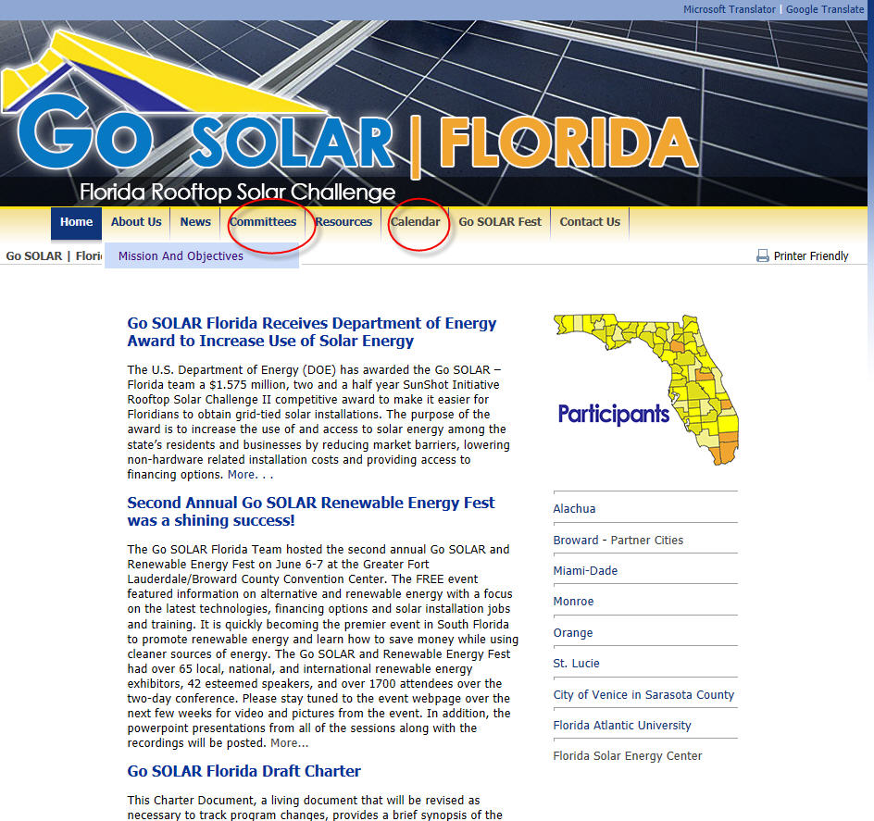

To find meeting dates, agendas, minutes and/or presentations, click on Calendar (see red circle above) and this page will open:

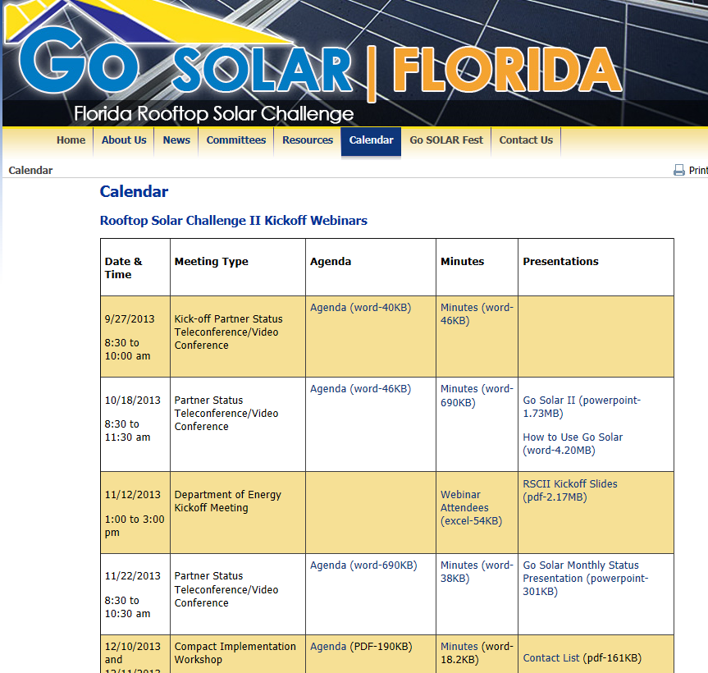

To read about committees click on the red circled committees and get four options:
- Financial Options
- Marketing
- Permitting Systems
- Planning & Zoning. The Financial Options page is listed below:

