GoSolar Florida
Florida Rooftop Solar Permitting Resource Center (FRSPRC)
PV System Design Certification Business Requirements

Table of Contents

Definitions 2
Introduction 3
Objective 1 – System Design Tool 4
Objective 2 – Code Compliant Documentation 5
Objective 3 – Standardized Output 6
Overview Diagram 7

Definitions

AHJ Agency Having Jurisdiction
API Application Program Interface (software that multiple computer systems use to communicate with each other)
ASCE 7 ASCE/SEI 7 Standard: Minimum Design Loads For Buildings and Other Structures
Sandbox An area in which customers can play with and visualize different PV system panel distributions upon their individual homes or businesses. The sandbox would not require any technical data and would not provide plans.
DOE Department of Energy
FRSPRC Florida Rooftop Solar Permitting Resource Center
FSEC Florida Solar Energy Center
kW kilowatt (one thousand (10³) watts)
NEC NFPA: National Electrical Code
NFPA National Fire Protection Association
PDF Portable Document Format (Adobe)
PV Photovoltaic (“generating current or voltage when illuminated”)
GoSolar 1 A Broward County pilot project that allows contractors to obtain solar rooftop PV construction permits online in just a few minutes, within any of 14 partner jurisdictions, using a preapproved set of designs.

Introduction
This document describes the Web-related work to be completed under the auspices of the Department of Energy’s (DOE’s) Go SOLAR Florida initiative (DE-FOA-000788).
PV system design, permitting, installation, and commissioning is currently a disconnected and cumbersome process in most instances. This adds to increased cost and creates delays in project completion; which result in lost sales, frustrated installers, and unhappy customers.
While safety, system performance, and consumer value cannot be sacrificed for the sake of expediency, the highest level of quality can be achieved through optimization of the process and standardization of the documentation requirements. The objective is to complete a comprehensive suite of design tools that serve industry, customers, and code officials. This is done by automating much of the process and standardizing formats. Code checks are completed with transparency and detail to assure compliance and safety.
The scope of this effort is to develop system that will produce a set of PV system design drawings and documents that are code compliant and ready for fast-track permitting. There will be minimal user inputs and all documentation will be in a standardized format that installers, plans examiners, field inspectors, and system owners clan clearly and completely understand. Key points include:
- Minimize user inputs to avoid errors
- Automate the electrical design process (wire sizing, breakers specifications, etc)
- Automate the structural design process (wind load calculations, anchoring, etc)
- Maintain Flexibility in system configuration options for module/inverter pairing and array attachment methods
- Built in code checking and validation (NEC, ASCE 7, FL Building Code, etc)
- Standardize the format of the drawings and documents for consistency and ease of use
- Produce outputs that are compatible with existing permitting processes
- Organize and publish references and resources for use by consumers, contractors, and agencies

Objective 1 – System Design Tool
The system design tool is divided into two modules that complete the PV system design, one for the electrical schematics and one for the structural components. These modules will be developed and maintained separately, but functionally will be indiscernible to the user.
Plans generation
A system details collection form created under the website development portion of the overall project will pass the user inputs to the design tool. User inputs include major components such as: PV module model, inverter model and racking system choice. Minor BOS components to complete the system include: wire type, junction boxes, and circuit breakers.
Major component details are maintained in a database with data sheets, specifications, and safety information (UL listing, Miami-Dade County product approval, etc). Users will make choices from a tiered menu system. This allows for flexibility and accommodates a wide variety of components combinations. Minor components will be automatically specified with the option to select alternates for advanced users.
The system will prevent users from making incompatible equipment choices. The design tools will verify electrical parameters and structural requirements and filter the lists of components automatically. These checks will optimize and ensure system performance.
Plans and documents will be generated ‘on the fly’ by drawing from data bases and performing calculations specific to the initial choices selected by the user. The complete package is customized for each instance. There are no limitations of ‘static’ plans.
Currently, there are several PV design tools offered by component manufacturers. However, these are usually limited to that manufacturers components. The system design tool developed under this project is intended to be comprehensive and modular so that it can be expanded to add new equipment as it enters the marketplace.
When possible, collaboration will occur with existing design tools and other under development by DOE awardees or commercial efforts. Some of these may include:
Applied Technology Council - Wind Speed Web Site
http://windspeed.atcouncil.org/
Solar ABCS - Temperature Map
http://www.solarabcs.org/about/publications/reports/expedited-permit/map/index.html
Sun Number - Sun Number Score
http://www.sunnumber.com/
Simply Civic – Process Tools
http://simplycivic.com/
Objective 2 – Code Compliant Documentation
Code requirements are incorporated into the decision process and as with equipment compatibility, users will not be able to make choices that are not code compliant. Tables and notes clearly show the calculations and field requirements for safe installations.
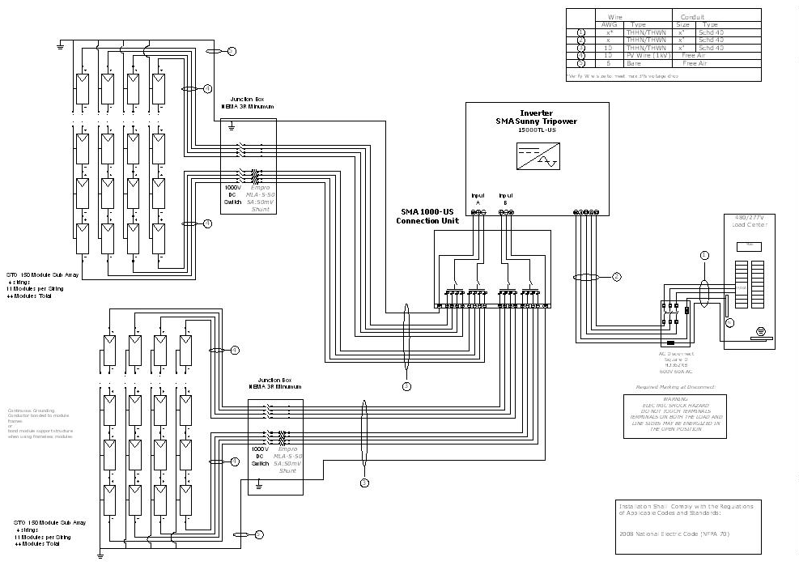
Figure 1 Sample electrical schematic

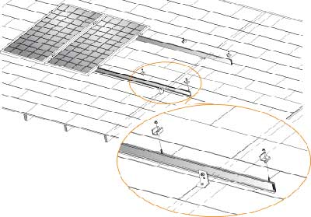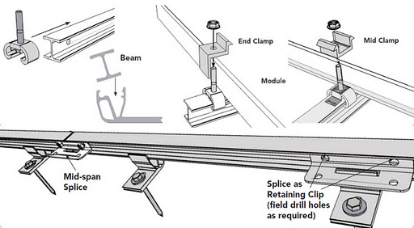
Figure 2 Sample structural isometric drawings (Unirac)

Objective 3 – Standardized output
In addition to the standardized ‘look and feel’ of the user interface and the plans format, the user data parameters and possibly the technical information and calculations can be compiled in a standard exchange format. This allows options for partners and future users to incorporate the plans generated by the system design tool to be imported easily into their process.
To achieve this objective, coordination is required between the development team and the various partners during the iterative process of determining the requirements of the data exchange. A complete and seamless transition from the plans generation module to the partner permitting site is the goal. It is understood that this is a very ambitious undertaking. However, clearly understanding what is required by the partners for the permitting process is very valuable in developing the standardized code compliant documentation and ensuring that the package is comprehensive and complete. This benefits users in jurisdictions that do not have electronic permitting available to them. Applicants and Code officials can be confident that the package is complete which speeds the permitting process even with paper documents.
Part of this objective is to engage the partners and code officials in dialogue with the developers to create a system that is simple for users to work with and meets all the regulatory needs and concerns regarding safety.

Overview Diagram

