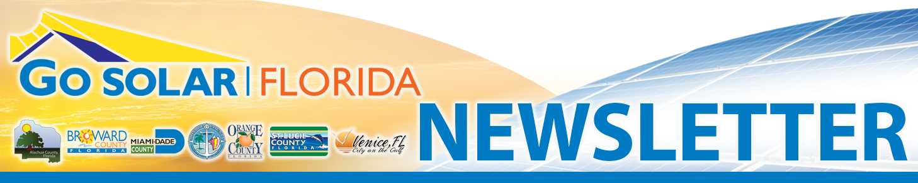
January | 2015  Go Solar Florida Website  Go Solar Florida Meetings & Upcoming Events  Go Solar Florida News  Go Solar Florida Contacts  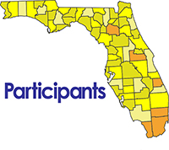  Alachua  Broward - Partner Cities  Miami-Dade  Monroe  Orange  St. Lucie  City of Venice in Sarasota County  Florida Atlantic University  Florida Solar Energy Center  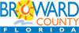  email: gosolar@broward.org  Phone: 954-519-1260  To submit articles, please email gosolar@broward.org  This material is based upon work supported by the U.S. Department of Energy and the Go SOLAR Florida Team under Award Number DE-EE006309.  Disclaimer: “This report was prepared as an account of work sponsored by an agency of the United States Government. Neither the United States Government nor any agency thereof, nor any of their employees, makes any warranty, express or implied, or assumes any legal liability or responsibility for the accuracy, completeness, or usefulness of any information, apparatus, product, or process disclosed, or represents that its use would not infringe privately owned rights. Reference herein to any specific commercial product, process, or service by trade name, trademark, manufacturer, or otherwise does not necessarily constitute or imply its endorsement, recommendation, or favoring by the United States Government or any agency thereof. The views and opinions of authors expressed herein do not necessarily state or reflect those of the United States Government or any agency thereof.”  Cost: reference funding from DOE under Award Number DE-EE006309.   | Upcoming Net Metering and Solar Rights Workshops  Go Solar Florida Workshop #1: Solar Rights  Hosted by Orange County  January 28, 2015  9:00 to 11:30 am  UF/IFAS Extension Education Center – Orange County Auditorium  6021 South Conway Road  Orlando, FL 32812-3604  This workshop is designed to educate Residents, Building Officials, Contractors, and Community Association Managers about solar access and the legal right to install rooftop solar systems.  Attendance is free, but pre-registration via Eventbrite is required.  Register for Solar Rights hosted in Orange County  For more information, contact Colleen Kettles at FSEC: ckettles@fsec.ucf.edu  Note: Two other Solar Rights Workshops are scheduled which will take place in Broward County on 2/12/2015 and in Alachua County on 2/18/2015. One additional workshop will be scheduled in Miami-Dade County, but a date and location have not yet been determined. Stay tuned to the Go SOLAR Florida website for more details and to register to attend.  Go Solar Florida Workshop #2: Net Metering and Interconnection  January 28, 2015  1:00 to 4:00 pm  UF/IFAS Extension Education Center – Orange County Auditorium  6021 South Conway Road  Orlando, FL 32812-3604  This workshop seeks to promote collaboration on consistent, statewide net metering and interconnection standards within the State of Florida.  Attendance is free, but pre-registration via Eventbrite is required.  Register for Net Metering hosted in Orange County  For more information, contact Cathy Randazzo at CRANDAZZO@broward.org  Please note: there are two (2) workshops scheduled on this date at this location. You may attend either or both workshops; however you must register for each one separately.  Solar Financing Information Cards for Homeowners, Businesses, and Local Governments have been posted online  The Go SOLAR Florida team has developed Solar Financing Information cards to help businesses, homeowners, and local governments understand options for financing solar energy.  Local governments, businesses, and homeowners have more choices than ever for obtaining electricity at competitive rates from solar photovoltaic (PV) systems. It is possible to enjoy both the environmental benefits of solar power and financial gain. In states with fairly low-cost electricity, such as Florida, a combination of policy levers and financial incentives may need to be applied as a catalyst to build market momentum to make solar PV systems truly competitive with, or even cheaper than, conventional power sources.  Over the last several years the price of solar PV panels has dropped. The price of electricity generated by those panels is approaching parity with traditional generation (fueled by coal, oil, natural gas, or nuclear). Since 2011, the average price of a completed PV system has dropped by 33 percent.  To help local governments in Florida understand their options for financing rooftop solar systems — on facilities, homes and businesses — the Go SOLAR Florida partners have published a Florida Solar Financing Action Plan. See the reverse side for Action Steps from the Plan, and visit the Go SOLAR Florida website to download the full document.  Partner Highlight- Miami-Dade  Miami Dade has been an integral partner in the Go-Solar effort and has been especially active in the creation of a structural plans system. This system will be integrated into the online electrical plans system that the Florida Solar Energy Center (FSEC) is currently creating. This is a major undertaking for Miami Dade, requiring very specialized technical expertise and many hours developing the questions and steps required to capture all the project information and data needed to create structural drawings for rooftop solar PV systems. Also, they have created the algorithms to take the required input data and calculate the requirements per code of the different components of the system. The calculation results and other information gathered, along with the electrical system design, will be used to create the permit ready structural and electrical drawings that will be generated as part of the plans system being created by FSEC.  Southeast Florida Regional Climate Compact receives Climate Action Champion designation from the Department of Energy  The US Department of Energy (DOE) has recognized the Southeast Florida Regional Climate Change Compact (“Compact”) as Climate Action Champions following a nationwide competition.  Only sixteen cities, regions, and tribal governments across the country were selected as the first group of Climate Action Champions. Partners of the 4-County SE Florida Regional Climate Compact (Broward, Miami-Dade, Monroe, and Palm Beach) join Seattle, San Francisco, Portland (OR), Boston, Minneapolis, the DC metro area, and other climate-leader communities.  The designation honors the “decisive action to cut carbon pollution and build resilience” already undertaken by the four Compact counties—Broward, Palm Beach, Miami-Dade, and Monroe. Since its establishment in 2009, the Compact has produced a series of technical documents providing a common framework for planning, including a unified sea level rise projection; published a five-year Regional Climate Action Plan (RCAP) and undertaken significant efforts to implement its 110 recommendations; and held annual summits engaging hundreds of local and regional leaders.  According to documents released by the White House, “selected communities will benefit from facilitated peer-to-peer learning and mentorship and targeted support from a range of Federal programs.” Each Champion will also receive a national coordinator to help connect and communicate with federal agencies, foundations, and organizations, and take full advantage of federal funding opportunities and technical assistance programs.  In their application, the Compact counties reaffirmed individual county-level greenhouse gas emissions reduction targets and identified region-wide goals of 10 percent reduction by 2020 and 80 percent by 2050. The Climate Action Champion award will significantly assist Compact efforts in meeting these targets and build a more efficient, resilient region.  The Compact, the nation’s leading example of coordinated regional climate action, was also recently highlighted as a model in the Third National Climate Assessment and the report of the President’s State, Local, and Tribal Leaders Task Force on Climate Preparedness and Resilience. For more information visit www.southeastfloridaclimatecompact.org/
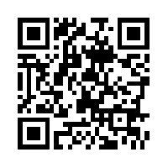   | Go SOLAR Florida Newsletter, an ePublication from the Go SOLAR Florida Team,  is produced by the Go Solar Florida Marketing Committee. Address questions concerning articles to 954-519-1260.  To subscribe or unsubscribe to this newsletter, email gosolar@broward.org.  Go Solar Florida Website

