AGENDA
Parks and Recreation Advisory Board Meeting
Friday  May 4, 2018  7:30 a.m. | 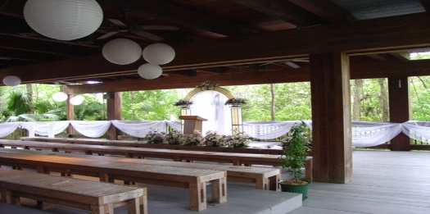 | Fern Forest Nature Center  Royal Fern Hall  201 Lyons Rd. South  Coconut Creek, FL 33063

Call to Order

Pledge of Allegiance

Attendance

Public Comment

Approval of Minutes – March 1, 2018

Park Manager’s Report – Nikki Hochberg, Parks Manager

Bond Construction Update – Jim Federici, P.E., Manager, Parks Planning and Design

Parks Foundation Update – Parks Staff

Parks and Recreation Division Update – Dan West, Director

Old Business
Board Meeting Start Time
FY 2018 Goals and Objectives
Parks Quality Survey Program

New Business

Adjournment

Next Meeting: Friday, August 3, 2018, at 7:30 a.m.
Markham Park Target Range
Club House Meeting Room
16001 W. State Rd. 84
Sunrise, FL 33326
954-357-5198

