FACT SHEET
OPEN BURNING OF HURRICANE DEBRIS
Updated September 2010

Who is allowed to conduct open burning of hurricane debris?
- Only county and municipal government entities or their agents are authorized to conduct open burning of hurricane generated vegetative debris.

Who authorizes open burning of hurricane debris?
- The State of Florida Department of Environmental Protection, Emergency Final Order (EFO) for Hurricanes authorizes local governments or their agents to conduct open burning of hurricane debris using an air curtain incinerator (ACI).

What kind of material may be burned?
- Only burning of hurricane vegetative debris and untreated (unpainted and non-pressure treated) wood may be burned.

Is open pile burning of hurricane debris allowed?
- No. Broward County ordinances do not allow open pile burning of hurricane debris.

What is an air curtain incinerator?
- An air curtain incinerator is a combustion device that directs high velocity air into a burn chamber with vertical walls, in such a manner as to maintain a curtain of air over the surface of the chamber and a recirculation motion of air under the curtain (See Figure 1). The burn chamber containing material to be burned may be either an earthen pit or an above-ground refractory-lined fire box (Figures 2 & 3).

How does an ACI operate?
- High velocity air is directed across and downwards at an angle into a pit or fire box creating an air curtain on top and a rotational turbulence within the pit or fire box. The rotational turbulence provides an oxygen enriched environment within the combustion zone which accelerates the combustion process by raising temperatures to approximately 1,500 º F. If the ACI is properly operated, the high velocity air curtain traps unburned particulates until they are completely consumed.
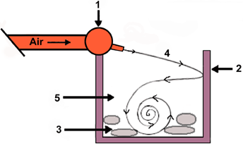
- Air curtain incinerator machine manifold and nozzles directing high velocity air into a refractory-lined fire box or earthen pit.
- Refractory-lined wall or earthen wall.
- Material to be burned.
- Initial air flow forms a high velocity curtain over fire.
- Continued air flow provides oxygen over fire keeping temperature high.

Figure 1. Air Curtain Incinerator Operation
- ACIs include fire boxes and trench burners. A fire box is a portable self-contained system with an air disbursement manifold located on one side of the combustion chamber (Figure 4). A trench burner is a portable, trailer mounted incineration system with a long manifold that delivers air into an earthen pit (Figures 5 & 6).

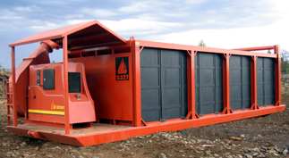
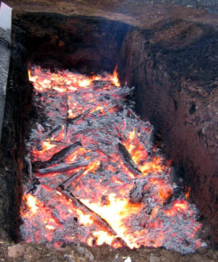

Figure 2. Earthen Pit Figure 3. Refractory-lined Fire Box

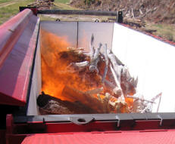
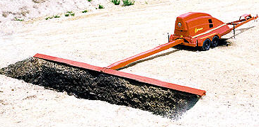

Figure 4. Fire Box with Air Disbursement Manifold Figure 5. Trench Burner

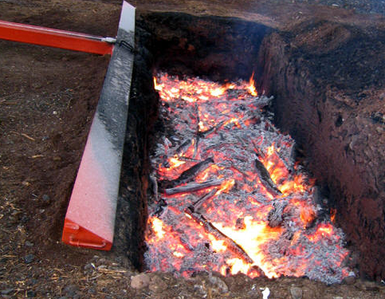

Figure 6. Trench Burner in Operation Over an Earthen Pit

What will be the impact on air pollution from operating ACIs?
- Air curtain incinerators are specifically designed to control smoke and other air pollutant emissions while operating. Operators of ACIs are required by the EFO to follow prescribed operational and maintenance practices to minimize public exposure to smoke. As an additional measure to minimize public exposure to smoke, the ACI operators monitor wind direction and cease loading the ACI with vegetative debris when the wind direction shifts toward residential areas.

- Accidental fires at hurricane debris management sites may occur while operating ACIs due to varying factors particular wind and wind direction. These fires may result in significant smoke and ash. Accidental fires are under the jurisdiction of the Municipal Fire Department or the Broward Sheriff’s Office Fire Rescue. Questions regarding accidental fires should be directed to those agencies.

How do I obtain more information about open burning of hurricane debris?

Contact: Broward County Air Quality Program
1 N. University Drive, Suite 203
Plantation, FL 33324
(954) 519-1260

Citizens are encouraged to call the Broward County Environmental Protection & Growth Management Department 24-hour complaint hot line at (954) 519-1499, with concerns regarding smoke from burn operations.

