CBE-SBE Stories: Broward County Convention Center (BCCC)
Learn more about the Certified Businesses working on the BCCC Expansion Project
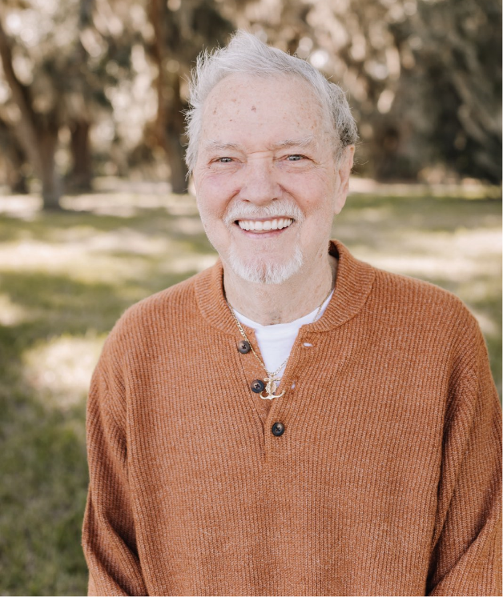
Surviving the Storms – 49 Years in Business
Carlos Hurst, President/Owner of Amos Supply Inc., has been in business since 1975. Surviving economic downturns and even a pandemic, Amos Supply Inc. has managed to stay afloat as one of Broward County’s local suppliers of waterworks and plumbing supplies. As a pioneer for the inclusion of small businesses in Broward County contracting, Carlos had served on Broward County’s Small Business Advisory Board pushing for the implementation of the County Business Enterprise (CBE) Program among other initiatives. In 2012, he achieved a tremendous victory for the small business community thanks to launch and implementation of the CBE program. “[The CBE program] saved my business,” said Carlos.
How did Amos Supply, Inc. survive? Access OESBD’s CBE/SBE Stories for key tips from Carlos.
Learn How to Get Certified
As a certified business (CBE/SBE/ACDBE/DBE), OESBD establishes goals and reserves solicitations creating access to billions of dollars in government procurement. Now is your time to Get Certified.

