NOTICE OF PUBLIC HEARING

Notice is hereby given of a public hearing to be held by the Board of County Commissioners (the "Board") of Broward County, Florida (the "County"), at its regularly scheduled meeting on June 14, 2022 at 10:00 a.m., or as soon thereafter as the matter may be heard, at 115 South Andrews Avenue, Room 422, Fort Lauderdale, Florida 33301. The hearing is scheduled for the purpose of receiving public comments concerning a plan of finance relating to the issuance by the County, in one or more series, of the not to exceed $225,000,000 Broward County, Florida Port Facilities Revenue Bonds, Series 2022 (AMT) (the "Series 2022 Bonds"). The proceeds of the Series 2022 Bonds shall be used to: (i) finance the Series 2022 Project (as hereinafter defined); (ii) fund the debt service reserve account with respect to the Series 2022 Bonds; (iii) fund capitalized interest for the Series 2022 Bonds; and (iv) pay certain costs of issuance and expenses relating to the Series 2022 Bonds, including, if deemed necessary and desirable by the County, payment of the premium for any municipal bond insurance policy and reserve account surety bond (the "Series 2022 Project").

The Series 2022 Project is defined as and consists of financing and refinancing, including through reimbursement, additional costs for (i) the lengthening of the County's existing deep-water turn-around area for cargo ships from approximately 900 feet to 2,400 feet to allow for up to five new cargo berths, (ii) the acquisition, design, construction, transportation, equipping and delivery of three (3) new container handling gantry cranes to be added to the County's existing gantry cranes in Southport to increase containerized cargo shipping capacity, (iii) terminal renovations and enhancements to cruise terminal 4, and ( iv) the design, construction and extension of crane rails to the full length of the County's existing Turning Notch berth and extension to utilize the County's existing gantry cranes and its new gantry cranes.

The County's Port Everglades property is located on the southeast coast of Florida, approximately 23 miles north of the City of Miami, and 48 miles south of the City of West Palm Beach, within the Cities of Fort Lauderdale, Hollywood, and Dania Beach. It is comprised of approximately 2,190 acres and divided into three distinct adjacent geographic areas: (i) Northport, which is the site of the Greater Fort Lauderdale/Broward County Convention Center, cruise operations and petroleum and dry bulk cargo operations; (ii) Midport, which is the site of container operations, cruise terminals, bulk cement operations, and neo-bulk operations; and (iii) Southport, which is currently dedicated to container operations as well as the Foreign-Trade Zone.

A map of Port Everglades is shown below:

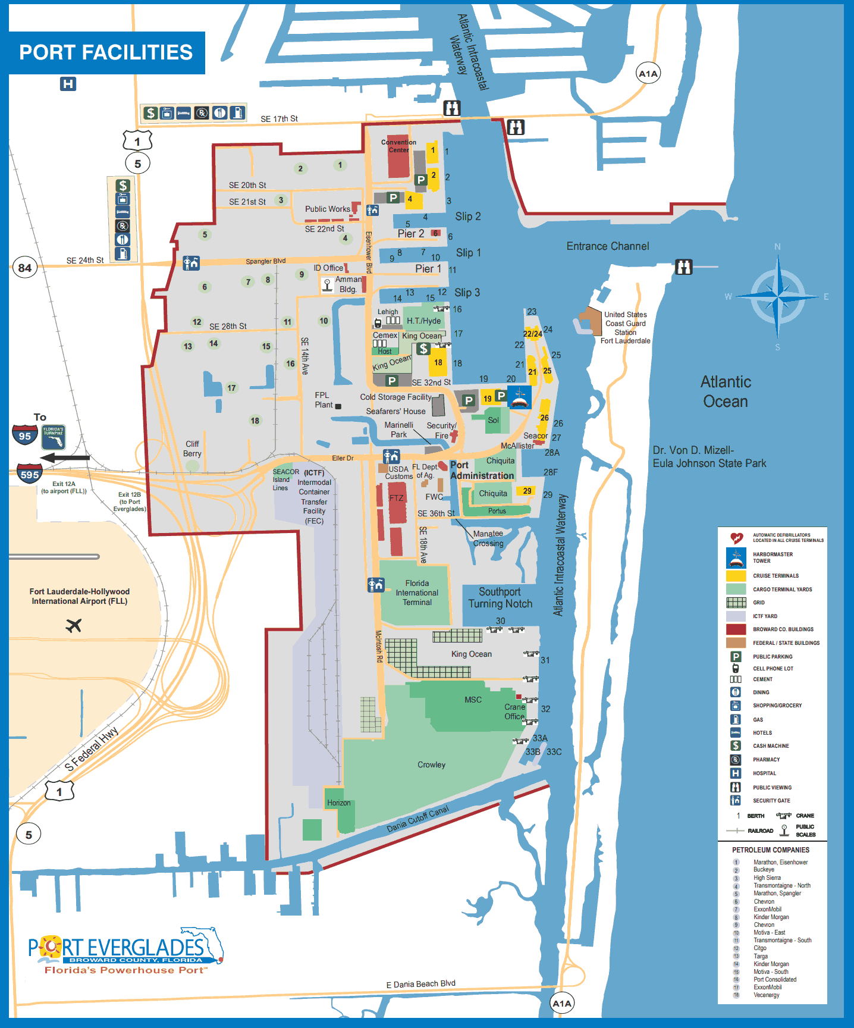
The owner of the Series 2022 Project shall be the County and the operator of the Series 2022 Project shall be the County, or an affiliate thereof or another entity chosen by the County.

A public hearing will be held pursuant to the requirements of Section 147(f) of the Internal Revenue Code of 1986, as amended (the "Code"), at the above referenced time and place in connection with the proposed issuance of the Series 2022 Bonds to finance and refinance, including through reimbursement, the costs of the Series 2022 Project described herein, at which time there will be an opportunity for persons to express their views on the foregoing. All interested taxpayers, property owners and citizens of Broward County, Florida are invited to attend this public hearing and, either personally or through their representative, will be given an opportunity to express their views concerning the Series 2022 Project to be financed and refinanced, including through reimbursement, with the proceeds of the Series 2022 Bonds. Written comments may be submitted on or before 4:00 p.m. June 13, 2022, to Broward County, Florida, 115 South Andrews Avenue, Suite 513, Fort Lauderdale, Florida 33301, Attention: Chief Financial Officer. If any auxiliary aids to communication are required, call the Office of Public Communications at (954) 357-6990 so that arrangements can be made in advance. Comments made at the hearing and for the consideration of the County will not bind the County as to any action it may take. Subsequent to the public hearing, the Board will consider whether to approve the issuance of the Series 2022 Bonds, as required by Section 147(f) of the Code.

SHOULD ANY PERSON DECIDE TO APPEAL ANY DECISION MADE BY THE COUNTY AT THIS HEARING, HE OR SHE WILL NEED A RECORD OF THE PROCEEDINGS AND HE OR SHE MAY NEED TO ENSURE THAT A VERBATIM RECORD OF THE PROCEEDINGS IS MADE, WHICH INCLUDES THE TESTIMONY AND EVIDENCE UPON WHICH THE APPEAL IS TO BE BASED.
Board of County Commissioners
of Broward County, Florida

