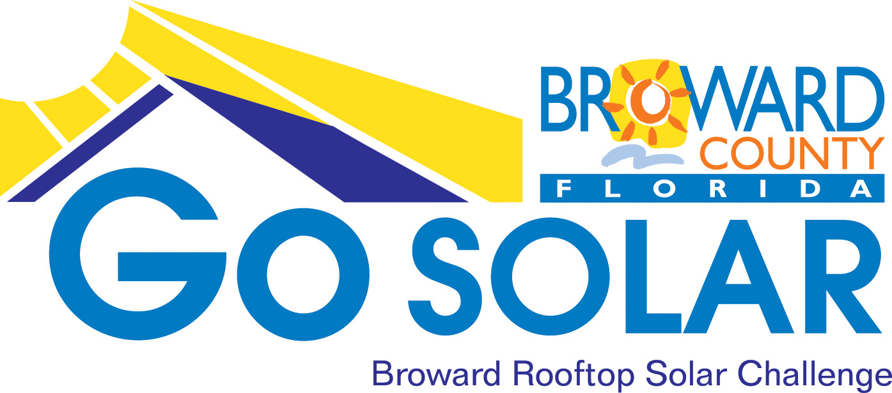
Standardized Permitting Committee Meeting Minutes
from Tuesday, August 21, 2012 9:00 a.m. Meeting
at Government Center West Hearing Room (2nd floor)
One North University Drive
Plantation, FL 33324
Minutes
- Welcome and introductions
- Go SOLAR Grant Mid-Year Status Update
- From Presentation (attached):
  - Go Solar Grant started Aug 15 2012
  - Permitting strategy review has been completed
  - Permitting web application is ready for launch; only waiting for design plans
  - Update on the grant:
- Committees established and draft ordinances completed;
- Permitting and outreach committees working; performed kick-off successfully;
- Market assessment for DOE completed before the grant (another to be completed after the grant process);
- Market assessment to be completed by every partner city; Phase 2 may occur based on DOE recommendation and market assessment results; Mr. Alfred Reed, with Broward County will be working with each partner city in obtaining answers to market assessment questions;
- All partner cities will be educated on the market assessment; BC has been working closely with FPL on net metering and interconnection questions for the market assessment;
- Partner cities conducting outreach in collaboration with BC (see Ken Dobies);
- Go Solar website has been developed; marketing plan has also been developed; webinars have been developed; Go Solar newsletter has been developed and published monthly;
- Inter-local agreements have been developed with all partner cities; model zoning ordinances have been approved; in-kind agreements for PV systems have been developed and published;
- Best management practices for net metering and interconnection have been developed;
- See presentation for other GoSolar tasks completed.

- On-going Challenges
- In-kind Exchange Agreement for Structural Designs
  - BC has not received any in-kind agreements for structural designs
  - BC has 6 months to complete the online permitting system
  - BC has been working with construction management to obtain structural design plans
  - BC is asking for ideas for how to obtain design plans

Q: You have not received proposed structural design plans and are currently asking for these plans in house from an in-house approved engineer?
A: Yes
Q: Does FSEC have any testing panels themselves being attached to support brackets? Do they certify these panels?
A: No FSEC do no certify. Neither does the University of Florida.
Comment from Mr. Jeff Halsey: FSEC is looking at this pilot program as providing the capability for them to certify this type of mounting. FSEC may consider the entire installation process of this pilot project certified if BC uses FSEC approved panels. FSEC doesn’t know anything about mounting therefore that is why FSEC is interested in this pilot project because right now they don’t certify mounting.
Comment: One of the mounting manufacturers….Unirac has a New Evolution system which if you go by their designs you get approval by several states including Florida (Unirac.com)
Comment from Mr. Jeff Halsey: BC’s job in this pilot project is permitting. There’s a business aspect to this program but we want a sustainable system; which continuously allows someone to jump in at any time. The only requirement is pre-approval. Mounting manufacturers can provide the plans free of charge because it’s a business interest for them but we are not dealing with the business end we are only dealing with permitting. Manufacturers submitted plans in a “test” network. However, when the time came no one truly submitted a set of plans to BC. BC will follow up with the manufacturers but in the interest of time we are going with plan B.
Comment: Go to Unirac.com where you can select the design and specifications of system, which then brings you to an engineering design with stamps from 10 different states from which FL is one.
Q: Are these design plans signed and sealed by engineers?
A: No (according to Mr. Ray Johnson). You still need a sign and seal from an engineer.
Comment from Mr. Ray Johnson: I don’t think you have a problem getting design plans, I am willing to provide engineer signed and sealed plans but we have an issue with the electrical drawings since they need more work. Electrical has to match structural and you have to pick one or the other to lead with. We lead with structural first then match it with electrical.
Comment from Mr. Jeff Halsey: The in-kind agreement has been out since June. You indicated you can provide these, why haven’t you?
Comment from Mr. Ray Johnson: Because we still don’t have a system that makes sense to go to market with electrical schematics defined proposed. I suggested that design is based on space and space is what will drive the electrical design. To start with the electrical design is something that is not being done in the industry anymore unless you’re talking about very large systems. I think you start with a workable space (e.g. zone 1) and then you fit into it brackets in such fashion…etc.
Comment from Mr. Jeff Halsey: You can propose plans that you are comfortable with and we can worry about the electrical challenges. This is a pilot. We just want to get the program started. All the technical challenges are valid and will be addressed but for now, this program is a proof of concept. DOE wants to see if this process works (the permitting process). BC wants to test the concept. If the concept works DOE will think about providing money going forward to implement and refine the concept. Critical details will be addressed later.
Comment from Ms. Maribel Feliciano: We are looking for at least one working design package that works for everyone.
Comment from Mr. Ray Johnson: We have packages available on various sizes. We haven’t offered it because we haven’t vetted out the electrical side but we have go to market designs.
Comment from Mr. Jeff Halsey: I realize the kind of time and effort you are all putting into this. But for right now BC is simply trying to focus on winning the challenge with a set of plans that works for now.
- Constraints called for designing a few sets of plans
- BC has proposed Zone 1 and Zone 2 designs (see Zone 1 and 2 Possible Scope Design Plan slide)
- Any comments of these designs?

Comment from Mr. Scott Schroeder: Information has been provided, the issue is do we have a system. We look at systems from the viewpoint of selling to the private sector. BC looks at systems that they can provide to another government agency. Our viewpoints are different and we need to align our viewpoints.

Comment: Standardization is difficult because of the many types of roofs.

Comment: Zone 1 and 2 Possible Scope slide is a good point of departure but there are so many other variables, ex. size of rafter, material, pull out strength, etc.

Comment from Ms. Maribel Feliciano: We understand that it is hard to standardize and we want to meet specific requirements. We don’t want to propose a system that is not feasible.

Comment: That is a typical generic chart of a roof…what are you looking for from us?

Comment from Ms. Maribel Feliciano: The chart is only defining the types of roof we want to be considered when designing.

Comment from Mr. Lenny: Ray has what you are looking for and what we need to pursue, you just need to reconcile the electrical portion of it.

Comment from Mr. Ray Johnson: Items on the chart are pretty straight forward. However, you would be hard pressed to find a 2kW system…they are pushing 3 or more. The 5,000 watt inverter is what is currently in the market. From there you put multiples. All is doable but the 5,000 is the more marketable system.

Comment from Ms. Maribel Feliciano: The 2kW system was put there for affordability. BC was thinking we didn’t want to develop expensive systems and have no other options, however, if 2kW is not realistic we don’t have to keep it.

Comment: A solar electric system should be with hot water; 2kW systems are sold but usually with a hot water system.

Comment: Every residential system designed is typically between 5 and 10kWs.

- Draft electrical schematics were sent out for comment; we received questions on the approval process; we explained this is a draft; thank you for all those who reviewed the electrical schematics and provided comments
- Final permit package: timeline is 1 to 2 months; shared with all partner city building officials and their staff; all comments will be incorporated and reviews; all comments go to BORA and then submitted to FSEC for review
- Training will be provided on the GOSolar online permitting system; one for building officials, another for solar contractors/the users; training will be about 1 hour and will be recorded which will be posted online in case anyone cannot attend
- After training, the online permitting system will be launched and marketed then evaluated; we would like to have at least 1 solar installation go through the on-line permitting system

Comment from Mr. Jeff Johnston: There is 1 solar PV system in Plantation currently to be installed; a 3kW system with battery back-up. We are working on the designs and engineering.
- Partner cities will focus on the inspection process; BC will work with city inspectors on the inspection process and its timeliness
- DOE will measure our success with a post-market assessment/test which will be the determinant for Phase II of the GOSolar Rooftop Solar Challenge.

Next Meeting and Facility Tour: Tuesday, September 25, 2012 - U.S. Solar Institute in Fort Lauderdale 10:00 a.m.

