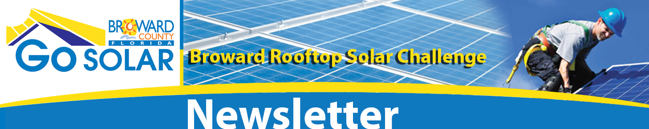
November | 2012  Home  Go SOLAR Highlights  Partners of the Month  Department of Energy  Success Stories  Solar Calendar  Standardized Permitting Committee  Financing Committee  Planning and Zoning Committee  Outreach Committee  Community Coordination  Go Solar Website | Go SOLAR Highlights  This past month, we completed the Financial Options workshop, completed one round of design plan review and two training sessions on the online permitting system for partner cities and contractors. Upcoming goals include completing our first permit package. Once accomplished we anticipate rapid completion and approval of additional packages as lessons learned on the first package should expedite the remaining plans approval. Finally, momentum is building for Go SOLAR Fest, which will be held January 25 and 26, 2013 at the Broward County Convention Center. Particularly if you are interested in helping increase solar installations within Broward County and Florida, we encourage your attendance and participation at the event. We are working to keep costs to a minimum to encourage participation – registration for the two-day event is only $50, exhibit space $100, and participation on Saturday only will be free (preregistration will be required). Thanks to all those who have contributed to moving Go SOLAR forward, and Happy Holiday!  The Go SOLAR Fest!  Friday January 25, 2013 - 8:30 a.m. - 5:00 p.m.  Saturday, January 26, 2013 - 8:30 a.m. to Noon  Greater Fort Lauderdale - Broward County Convention Center  1950 Eisenhower Blvd., Fort Lauderdale  Who Should Attend?  Local, State and Federal government officials, licensed solar and electrical contractors, financial institutions, solar installers, potential customers, legal experts and interested parties  Why Attend?:  The Go SOLAR Fest is an event highlighting the successes of the Go SOLAR Broward Rooftop Solar Challenge and it will include:  - Open forum discussion of solar challenges, solutions, and policy recommendations to advance solar regionally and statewide  - Overview of the Go SOLAR Online Permitting System  - Discussion of potential financing options for the installation of rooftop PV solar systems  - Description of solar rights in Florida and revisions to local zoning ordinances amongst partner cities  - Summary of best practices for interconnection and net metering  For more information visit www.broward.org/gogreen/gosolar  Request for Co-sponsorships  Broward County and the Go SOLAR Team are requesting Co-Sponsorships of Go SOLAR Fest.  In addition to celebrating the successful conclusion of the Rooftop Solar Challenge grant in a highly publicized, public forum, the Go SOLAR Fest will help Broward County continue the momentum established for increasing interest in photovoltaic rooftop panel installations by contractors, residents, businesses and other community partners. The Go SOLAR Fest will provide an opportunity for these interested parties to collaborate on additional steps to removing the barriers that are preventing Florida solar residential/commercial markets from growing faster, and work with local, state and federal subject matter experts to generate solutions and develop an action plan to implement them.  Sponsorship Opportunities  - Go SOLAR Fest Partner  - Platinum Sponsor  - Gold Sponsor  - Silver Sponsor  - Bronze Sponsor  For more information visit the Sponsorship page on the Go SOLAR Fest website at broward.org/GoGreen/GoSOLAR/Pages/RequestforCo-Sponsorship  Exhibitor Opportunities  Businesses are invited to interact with participants by displaying their services in the Exhibit Hall. Fees have been kept low to include small businesses that provide solar services such as installation, design, financing, insurance, technology, developing markets, policy and grid integration. Booth space is only $100 for Friday and Saturday. This includes lunch on Friday and coffee both days. Booth space going fast!  Registration for Friday is $50, attendance on Saturday is free. Pre-registration for both will be required.
 | Partner of the Month: City of Coconut Creek
This material is based upon work supported by the U.S. Department of Energy under Award Number DE EE0005701.  Disclaimer: “This report was prepared as an account of work sponsored by an agency of the United States Government. Neither the United States Government nor any agency thereof, nor any of their employees, makes any warranty, express or implied, or assumes any legal liability or responsibility for the accuracy, completeness, or usefulness of any information, apparatus, product, or process disclosed, or represents that its use would not infringe privately owned rights. Reference herein to any specific commercial product, process, or service by trade name, trademark, manufacturer, or otherwise does not necessarily constitute or imply its endorsement, recommendation, or favoring by the United States Government or any agency thereof. The views and opinions of authors expressed herein do not necessarily state or reflect those of the United States Government or any agency thereof.” | They call it a Blast for a reason!  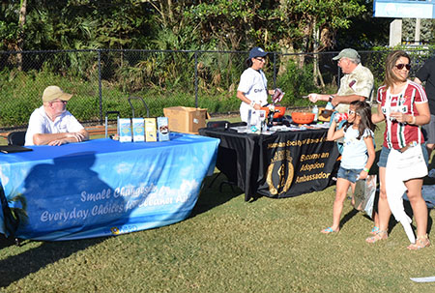  The City of Coconut Creek’s Halloween Blast was a big hit for residents and visitors of all ages. Despite the high winds lingering from Tropical Storm Sandy, close to 5,000 people enjoyed the carnival rides and foods, entertainment and Business Expo at Sabal Pines Park, Coconut Creek’s largest park.  Over forty local businesses showcased their goods and services while handing out sweets to children and adults dressed in costumes. Families stopped by the Go SOLAR booth to learn about the Broward Rooftop Solar Challenge and the benefits of solar energy.  The City of Coconut Creek is a participating partner of the Go SOLAR Team. The City promotes the program through their website, reception displays and social media.
Cost: reference funding from DOE Award Number DE-EE0005701.  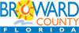  A SERVICE OF THE BROWARD COUNTY BOARD OF COUNTY COMMISSIONERS  broward.org/gogreen/gosolar  email: gosolar@broward.org  Phone: 954-519-1260  To submit articles, please email kdobies@broward.org | News from the Department of Energy  Investing in America’s Solar Workforce  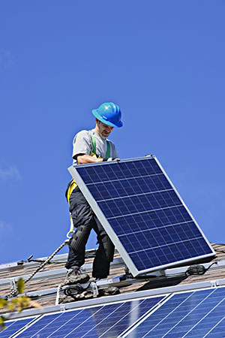  For the U.S. solar market to continue to expand, maintaining a skilled workforce remains tremendously important. This is why the Energy Department recently announced its support for the Photovoltaic Online Training (PVOT) program, a free online training tool specifically designed for code officials who grant permits and perform field inspections for residential solar installations.  Using video and photographs to illustrate the correct techniques, PVOT teaches participants how to perform safe solar installations. The online course provides in-depth training in a variety of subjects, including electrical requirements and expedited permitting processes. The end goal is to increase the reach and scale of training available to code officials across the country, while also establishing a consistent and streamlined approach to the residential solar inspection and installation process.  While geared to building and electrical code officials, PVOT is also appropriate for solar installers, architects, students and even consumers who are interested in the solar industry. The curriculum is compliant with current National Electrical Code requirements.  PVOT was developed by the Interstate Renewable Energy Council as part of the SunShot Initiative's Solar Instructor Training Network. PVOT is hosted on the National Training & Education Resource, an open-source online learning platform. To learn more, visit the PVOT website.
  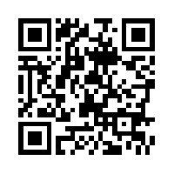 | Success Stories  The Go SOLAR Program makes news in Miramar  The City of Miramar has made concerted efforts to ensure that its residents are always fully aware of County programs that they may find beneficial. One of the ways make contact directly to residents is through their water bills. Miramar operates its own water and sewer system and provides the service directly to its residents. As part of its billing efforts, the City post messages on the back of over 33,000 water bills each month. That message generated many calls and requests for information about the Go SOLAR program online application system.  Miramar’s next effort is to post the GoSolar Fest event in its community newspaper, City Beat.

Solar Calendar
Friday & Saturday, January 25 & 26, 2013 – The Go SOLAR Fest!
The Go SOLAR Fest! is a Go SOLAR Broward Rooftop Solar Challenge team event highlighting successes during the grant year
Friday - 8 a.m. – 5 p.m., Saturday - 8:30 a.m. – Noon;
Broward County Convention Center, 1950 Eisenhower Blvd., Fort Lauderdale

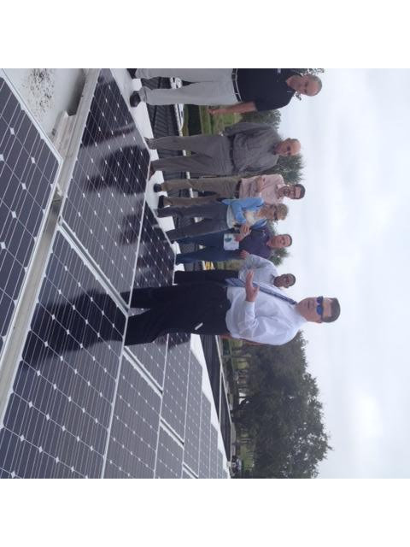
Broward County Go SOLAR Rooftop Solar Challenge Committees Update:

Standardized Permitting
JM Family Enterprise hosted the Go SOLAR Broward Rooftop Solar Challenge Standardized Permitting Committee meeting on Tuesday, November 20, 2012 provided an educational presentation of their solar projects, and a tour of their solar array. They have two arrays at their headquarters in Deerfield Beach and a third array at JM Lexus. The three 33-kW solar arrays became operational in October of last year.
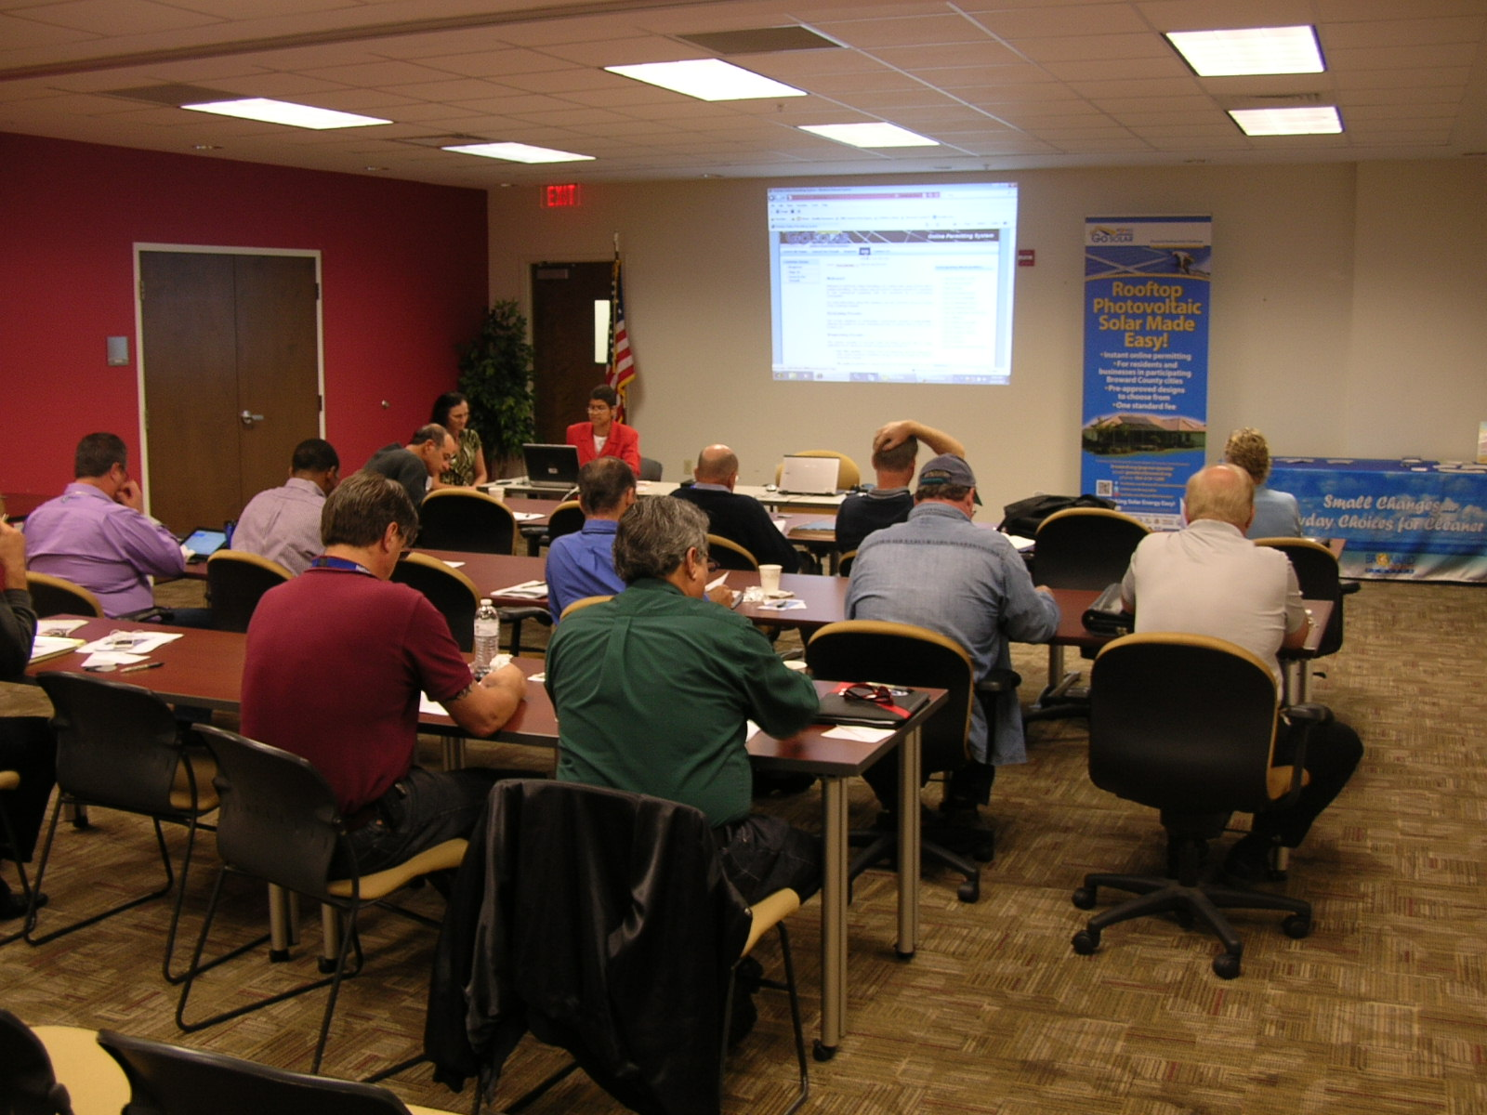
The Go SOLAR Team coordinated two training sessions for partner cities and contractors about the Go SOLAR Online Permitting system. Both sessions were very well attended and participants provided excellent feedback about the online application. Visit the Go SOLAR website for additional training resources.
Go SOLAR Permitting.

Financing
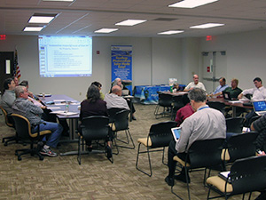
The Financial Committee met on October 30 to review the results of the Finance Survey and discuss Solar PV financing options for residential and small commercial structures as well as identify the benefits and challenges of each option. Key messages from the workshop related to the need for policy changes at the state level to encourage and support a solar market including a renewable portfolio standard and allowance of third party financing mechanisms such as power purchase agreements and community solar. Property owners are interested in better education and outreach on their financing option and for panel prices to decrease. The ability of customers to qualify for loans was discussed. Solar industry representatives emphasized the need for consistent incentives and rebate programs that allow the industry to become established and the availability of low interest (3.5 percent) loans. In general, solar financing is not a focus of local financial institutions at this time and may reflect a need for outreach to these institutions of the value of solar investment. The role of local and state government was also discussed. Meeting minutes and presentations may be found at www.broward.org/gogreen/gosolar under Committees.
Financing Survey Results
Broward County conducted a Rooftop Solar Photovoltaic (PV) Financing Survey on-line to better understand financing issues for three audiences: Property Owners, the Solar Industry and Financial Institutions. Key topics included awareness of financing options, financial barriers to installing Solar PV systems, interaction between solar industry and their customers, the relationship of solar industry with financial institution, and the role of government in supporting the financial side of Solar PV.
Go SOLAR Financing

Planning and Zoning
The Planning and Zoning Committee (PZC) has been meeting regularly since March to discuss provisions in local zoning codes to encourage rooftop solar installations. A model ordinance was developed to assist the partners in amending their respective zoning codes. To date, the County and 11 municipal partners have adopted solar-friendly zoning amendments to address rooftop solar installations. One municipal partner has scheduled an adoption hearing in mid-November and two municipal partners have scheduled adoption hearings in early December. Staff prepared a draft of “Planning and Zoning Best Practices,” which will be finalized by mid-December.
Go SOLAR Planning

Outreach
The Outreach Committee’s December meeting will be a discussion and presentation about Go SOLAR Fest. Go SOLAR Fest is an event highlighting the successes of the Go SOLAR Broward Rooftop Solar Challenge and it will include:
- Open forum discussion of solar challenges, solutions, and policy recommendations to advance solar regionally and statewide
- Overview of the Go SOLAR Online Permitting System
- Discussion of potential financing options for the installation of rooftop PV solar systems
- Description of solar rights in Florida and revisions to local zoning ordinances amongst partner cities
- Summary of best practices for interconnection and net metering
Local, State and Federal government officials, licensed solar and electrical contractors, financial institutions, solar installers, potential customers, legal experts and interested parties should attend.
For more information visit the Go SOLAR Website.

Community Coordination

Solar PV Installers, Manufacturers and Educational Institutions are Encouraged to Partner with Go SOLAR
Broward County’s Go SOLAR Team is seeking an Advantage Marketing agreement in two areas with solar PV installers, educational institutions, mounting manufacturers and the solar industry.
Solar PV Educational Displays: Co-Sponsorship Opportunity
Broward County is offering the opportunity of co-sponsorship on educational displays for the Government Center West lobby. The sponsor will provide and maintain a basic educational display for a three-month period about the benefits of solar energy. The display could include a solar panel or a cut-away of a panel for the public to see and touch (protected to avoid injury), a rack system, an inverter and any additional components that a resident or business would need to install a solar PV system. Also, the display should include educational signs and literature that the public can take away. Electricity will be provided. Available floor space would be a maximum of 4 feet by 10 feet.
Co-sponsorship Benefits
The company’s educational display will be available to all visitors to the Government Center West lobby. The company can provide educational information about their specific products and services. The company will be showcased as a sponsor on the Go SOLAR website, kiosk and e-newsletter.
The request for sponsorship announcement is posted on the Broward County Purchasing website

Solar PV Manufacturers Encouraged to Partner
with Go SOLAR
Broward County’s Go SOLAR Team is seeking an Advantage Marketing agreement with solar PV mounting manufacturers and the solar industry.
Through this agreement, companies will have the opportunity to become involved in the Broward County Go SOLAR challenge by providing an electronic set or sets of solar photovoltaic (solar PV) rooftop mounting system design plans (outlined in the agreement). In exchange, Broward County will include the company’s plans and required equipment list (as submitted under the agreement) as a design option in the Go Solar PV Online Permitting System. Release of the Advantage Marketing Agreement announcement is posted on the Broward County Purchasing website.
Go SOLAR Newsletter, a monthly ePublication from the Go SOLAR Broward Rooftop Solar Challenge Team,
is produced by the Go SOLAR Outreach Committee. Address questions concerning articles to 954-519-0313.
To subscribe or unsubscribe to this newsletter, email gosolar@broward.org.
broward.org/gogreen/gosolar

