AGENDA
Parks and Recreation Advisory Board Meeting
Friday  January 19, 2018  7:30 a.m. | 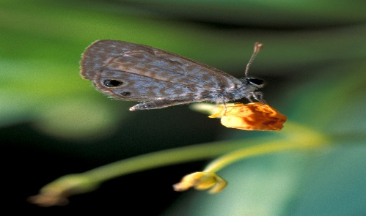 | Tradewinds Park & Stables  Conference Room  3600 W. Sample Rd.  Coconut Creek, FL 33073

Call to Order

Pledge of Allegiance

Attendance

Election of Chair/Vice Chair

Public Comment

Announcements:
New Board Member – Barry Harris, representing Commissioner Michael Udine, District 3

Approval of Minutes – December 1, 2017

Park Manager’s Report – Tim Waln, Parks Manager

Bond Construction Update – Jim Federici, P.E., Manager, Parks Planning and Design

Parks Foundation Update – Parks Staff

Parks and Recreation Division Update – Dan West, Director

Old Business

New Business
PAB Goals and Objectives: 2017 Review, 2018 Discussion

Adjournment

Next Meeting: Thursday, March 1, 2018, 6 p.m., followed by a Public Forum at 7 p.m.
T.Y. Park
3300 N. Park Rd.
Hollywood, FL 33021
954-357-8811

