AGENDA
Parks and Recreation Advisory Board Meeting
Friday  March 1, 2018  6 p.m. | 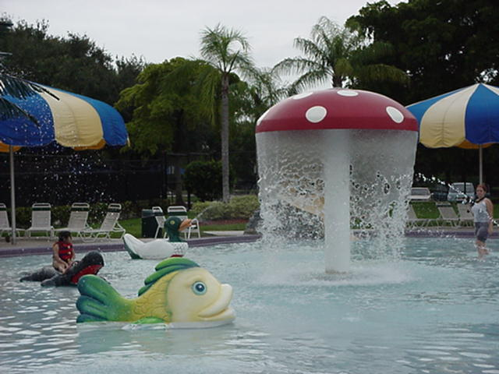 | T.Y. Park  Conference Room  3300 N. Park Rd.  Hollywood, FL 33021

REGULAR MEETING
Call to Order
Pledge of Allegiance
Attendance
Public Comment
Announcements
New Board Member Steven Lawson, appointed by Commissioner Geller, District 5
Old Business
Elections – Chair, Vice-Chair
Approval of Minutes – January 19, 2018
Park Manager’s Report – Debbie Battista, Parks Manager
Bond Construction Update – Jim Federici, P.E., Manager, Parks Planning and Design
Parks Foundation Update – Parks Staff
Parks and Recreation Division Update – Dan West, Director
New Business
Discussion about possibly changing the time when board meetings begin
Adjournment

PUBLIC FORUM
Call to Order
Public Comment
Adjournment

Next Meeting: Friday, May 4, 2018, at 7:30 a.m.
Fern Forest Nature Center
201 Lyons Rd. South, Coconut Creek, FL 33063
954-357-5198

