Why People Should Attend and Businesses Should Exhibit at the Third Annual Go SOLAR & Renewable Energy Fest
By: Danielle Hegedus

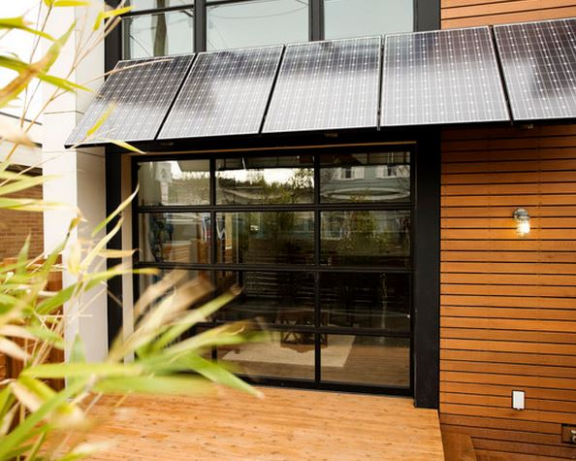
Via Modernize

Take advantage of a rewarding and FREE event and make plans to visit the Third Annual Go SOLAR and Renewable Energy Fest held at the Greater Fort Lauderdale/Broward County Convention Center in Fort Lauderdale on October 9-10, 2015. Here, homeowners can check out the latest in renewable energy technology that can dramatically lower utility bills and decrease your environmental footprint. This year’s event will also feature experts on thermal, geothermal, wind, and energy efficiency. This is also a great opportunity to speak directly with eco-friendly businesses and environmental experts to learn about the latest trends in renewable energy. Last year’s event had more that 65 local, national, and international renewable energy exhibitors, 42 esteemed speakers, and over 1,700 attendees. Due to popular demand, this year will feature even more exhibitors.

But Isn’t Solar Expensive?
Absolutely not! A dramatic increase in consumer demand, coupled with leaps in renewable energy technology, have made solar energy not just competitive with traditional fossil fuel energy sources, but cheaper! Plus, you can expect a great return on your investment through decades of savings on energy costs, not to mention a hefty increase in your property value. A recent study by the Berkeley Lab found that eco-friendly upgrades (especially solar) are also a great way to increase your home value. “Home buyers consistently have been willing to pay more for homes with host-owned solar photovoltaic (PV) energy systems—averaging about $4 per watt of PV installed—across various states, housing and PV markets, and home types. This equates to a premium of about $15,000 for a typical PV system.”

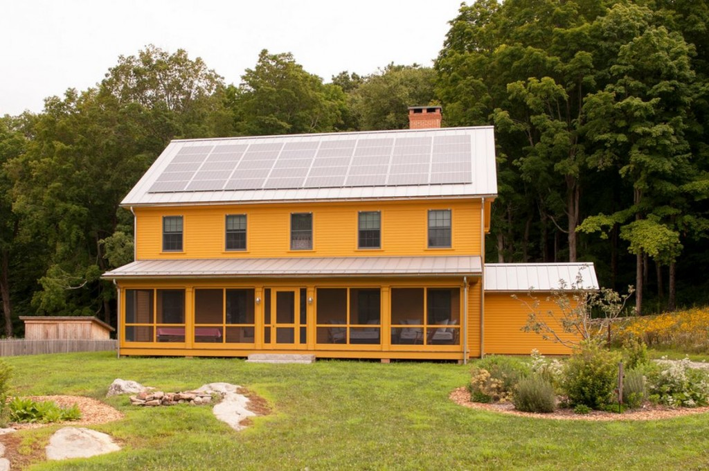
Via Modernize

Who Should Attend?
Home and business owners who are interested in saving money on energy costs and decreasing their environmental impact will have the opportunity to learn from renewable energy experts and meet directly with businesses who are working in their community to provide this technology.

Business owners will have a fantastic opportunity to connect with consumers who are ready to make the commitment to sustainable living. More than 1,700 residents, businesses, and government entities with an interest in alternative energy attended the 2014 event. As a business owner, there are also great opportunities to sponsor the event and really raise your visibility in the community. As a sponsor, your business will be in good company—Broward County is one of only 22 governments or organizations in the nation to receive funds to implement a solar energy program for residents and businesses. You’ll also have the opportunity to meet and network with top-decision makers and industry leaders representing companies from local, state, and federal levels from around the country. As another exciting perk, there will also be various alternative-energy vehicles on display (Tesla, Chevy Volt, Nissan Leaf, BMW i3 and i8, Cadillac ELR, and Ford Fusion), so here’s your chance to learn about their benefits without a pressuring salesman.

The Go Solar and Renewable Energy Fest is also a great way for construction, landscape, and engineering professionals to stay current on new trends for their industries. If you are a member of any of the following professional boards, you may qualify for 4 free Continuing Education Units being offered during the event on October 9, 2015:

• Construction Industry Licensing Board (CILB)
• Building Code Administrators and Inspectors (BCAI)
• Board of Landscape Architects (BOLA)
• Electrical Contractors Licensing Board (ELCB)
• Florida Board of Professional Engineers (FBPE)

To attend, simply fill out this form (“Advanced Residential Energy Code Compliance: Methods, Tools, and Verification”) and fax to (352) 392-9033. Forms for all CEUs are available at www.gosolarflorida.org.

Don’t forget to register for this free opportunity, and check out Modernize for ideas about how to make your home more eco-friendly! Go SOLAR Florida is a partnership between Alachua, Broward, Miami-Dade, Monroe, Orange, St. Lucie, City of Venice in Sarasota County, Florida Atlantic University, and Florida Solar Energy Center.

Convention Center Address
1950 EISENHOWER BOULEVARD, FORT LAUDERDALE, FL 33316
PHONE: 954.765.5900 ♦ FAX: 954.763.9551

For more information, contact GoSolar@broward.org

